Year 2 |  | Islamic Beliefs | Summer Term
Key Vocabulary |  | 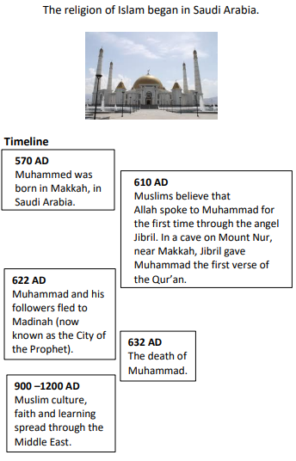 | 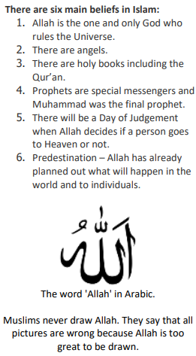
Islam | a: The civilization built upon the Islamic faith.  b: The group of modern nations in which Islam is the main religion.
Allah | Personal name of God who is the one and only creator of the universe.
Arabic | The language the Qur’an is written in.
Prophets | Individuals who were sent by God to demonstrate ideal human behaviour and to spread God's message on Earth.
Mohammed | The last prophet and founder of Islam.
Qur’an | Islamic sacred book, Muslims believe that these are the exact words spoken by Allah.
Muslim | A follower of the religion of Islam.
Mosque | A mosque is a place of worship for Muslims.
Mecca | The place for pilgrimage, the place where Prophet was born and also the direction towards which Muslims face when praying.
Five Pillars | Shahadah – Faith  Salaah – Prayer  Sawn – Fasting  Zakat – Charity  Hajj – Pilgrimage

