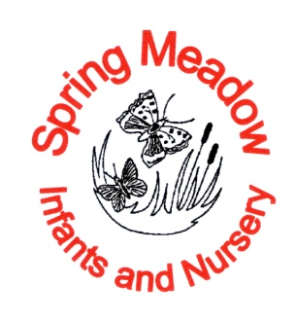

Maths Calculation Policy

Written by: Claire Tomlin
Date: September 2026
To be reviewed October 2027

The calculation policy has been taken and adapted from White Rose Maths to support the teaching and learning of maths at Spring Meadow Infant and Nursery School.
The calculation policy is divided into four sections: addition, subtraction, multiplication and division. At the start of each section, there is an overview of the progression of skills. The calculation policy follows the same concrete, pictorial, abstract approach as the main schemes of learning. Where appropriate, sentence stems and key questions are included alongside the key representations. Where skills are divided into more than one section across the page, there is a progression in the level of difficulty from left to right.



Progression of skills – Addition
Year group | Skill
Nursery | - Subitise to 3  - Count how many  - Make numbers to 5  - Add 1 more (through songs and rhymes)
Reception | - Conceptually subitise to 5  - 1 more  - Notice the composition of numbers within 10  - Combine 2 groups  - Add more
Year 1 | - Add together  - Add more  - Bonds within 10  - Related facts within 20  - Missing numbers
Year 2 | - Add 1s to any number (related facts)  - Add three 1-digit numbers  - Add across a 10  - Add multiples of 10  - Add 10s to any number  - Add two 2-digit numbers (not across a ten)  - Add two 2-digit numbers (across a ten)  - Missing numbers

Nursery | • Begin to have an understanding of numbers to 5  • We recommend focusing on noticing and representing small quantities, perceptual subitising and counting.
Progression of skills | Key representations
Subitise to 3  Instantly see how many. | How many do you see?    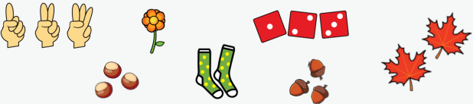
Count how many  Begin to count objects using 1-1 correspondence | How many are there?  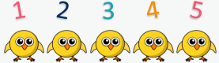 | Count out … from a larger group. E.g. Collect 3 beanbags for a game.    
Make numbers to 5 Start by showing 1, 2 and 3 using fingers. | Show me…    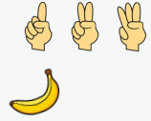 | Begin to link numerals to quantities.  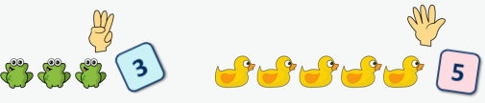
Add 1 more  Through stories, songs and rhymes. |   How many do I have now?

Reception | - Have a deep understanding of numbers to 10, including the composition of each number.  - Subitise (recognise quantities without counting) up to 5  - Automatically recall (without reference to rhymes, counting or other aids) number bonds up to 5 and some number bonds to 10, including double facts.
Progression of skills | Key representations
Conceptually subitise to 5  Notice the parts that make up the whole. | What do you see?  How do you see it? 
1 more  Continue to link to stories, songs and rhymes. | 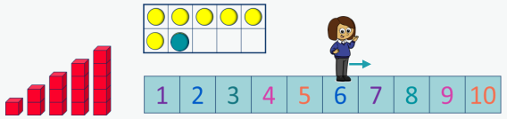  1 more than … is …
Notice the composition of numbers within 10 Link to stories, songs and rhymes | 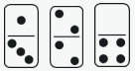  H ow many…?  How many…?  How many altogether?   | How many ways can you make…?  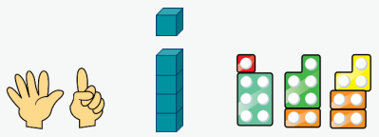
Combine 2 groups  2 groups are combined to find the total. |   There are ….  There are ….    There are …. altogether. | …. and …. make ….  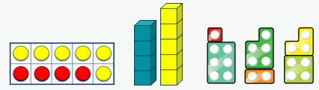
Add more  A quantity is increased. | First… Then…. Now….  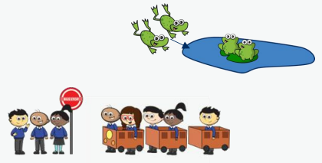 | I have …. I add …. more. Now I have….  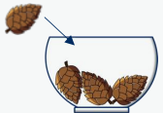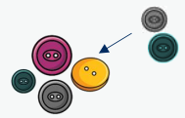  

Year 1 | - Read, write and interpret mathematical statements involving addition (+) and equals (=) signs.  - Represent and use number bonds within 20  - Add 1-digit and 2-digit numbers to 20, including zero.  - Solve one-step problems that involve addition, using concrete objects and pictorial representations, and missing number problems such as 7 = + 2
Progression of skills | Key representations
Progression of skills | concrete | pictorial | abstract
Add together (aggregation)  2 quantities are combined to find the total. | There are … There are … There are … altogether.  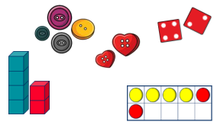 | …is a part.  … is a part.  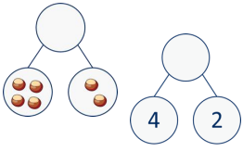  … is the whole. | ... plus … is equal to …  … is equal to …. + …  4 + 2 = 6  2 + 4 = 6  6 = 4 + 2  6 = 2 + 4
Add more (augmentation)  A quantity is increased. | First… Then… Now…  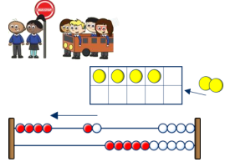 | 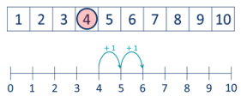  I start at … I jump on … I land on … | ... plus … is equal to …  … is equal to …. + …  4 + 2 = 6  2 + 4 = 6  6 = 4 + 2  6 = 2 + 4
Bonds within 10 Include bonds for each number within 10 Encourage children to notice patterns. | … is made of … and …  … and … make …  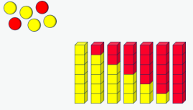 | … can be partitioned into … and …  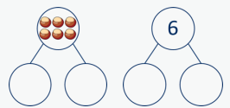 | … plus … is equal to … 6 + 0 = 6  5 + 1 = 6  4 + 2 = 6  3 + 3 = 6  2 + 4 = 6  1 + 5 = 6  0 + 6 = 6
Related facts within 20 Make links to known facts. | I know that … and ... = … so … and … = ...  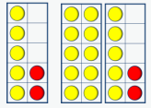 | … more than … is …  so … more than … is …  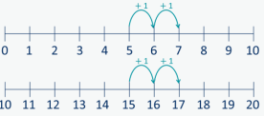 | What patterns do you notice?  5 + 2 = 7  15 + 2 = 17  7 = 5 + 2  17 = 15 + 2
Missing numbers  Make links to known facts. | How many more do you need to make …?  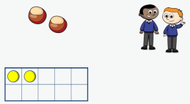 | If … is the whole and … is a part, the other part must be…  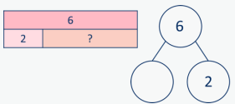 | … plus … is equal to …  2 + = 6  6 = 2 +  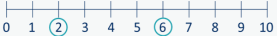

Year 2 | - Recall and use addition facts to 20 fluently, and derive and use related facts up to 100  - Add numbers using concrete objects, pictorial representations, and mentally, including:  • a two-digit number and 1s  • a two-digit number and 10s  • 2 two-digit numbers  • adding 3 one-digit numbers  • Recognise and use the inverse relationship between addition and subtraction and use  - this to check calculations and solve missing number problems
Progression of skills | Key representations
Progression of skills | concrete | pictorial |  | abstract
Add ones to any number (related facts) Make links to known facts. | I know that … and ... = …  so … and … = ...  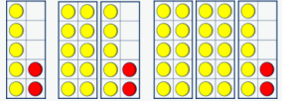 | … more than … is …  so … more than … is …  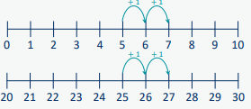 |  | What do you notice? Can you continue the pattern?  5 + 2 = 7  15 + 2 = 17  25 + 2 = 27…
Add ones to any number (related facts) Make links to known facts. | … and … are a bond to 10  10 + … = …  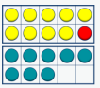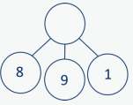  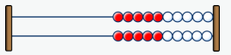 | 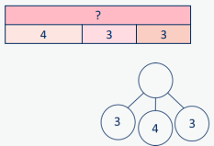  Double … + … = … |  | What do you notice?  Which addition is the easiest to calculate?  8 + 9 + 1 =  8 + 1 + 9 =  9 + 1 + 8 =
Add across a 10 Partition the number being added to make a full ten. | … can be partitioned into … and …  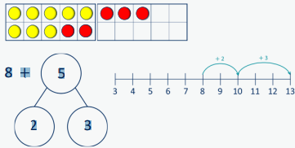 |  | I add … to get to … then I add … 8 + 5 = 13  28 + 5 = 33  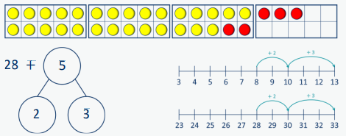
Add multiples of 10 Make links to known facts within ten | … ones + … ones = … ones  so … tens + … tens = … tens  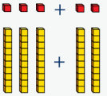  3 + 2 = 5  30 + 20 = 50 | What is the same?  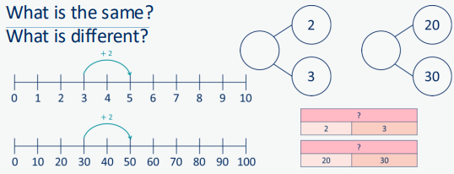  What is different?
Add 10s to any number Make links to known facts. | … tens + … tens = … tens … tens and … ones = …  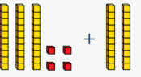 | 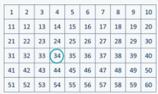  To add … I need to add 10 … times. |  | I know that … and ... = …  so … and … = ...  30 + 20 = 50  34 + 20 = 54
Add 2-digit numbers (not across a ten) Lining up ones and tens in columns will support with later written methods. | 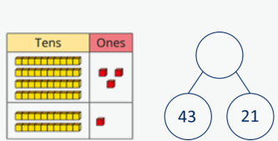  … ones + … ones = … ones 3 ones + 1 one = 4 ones  4 tens +2 tens = 6 tens  6 tens + 4 ones = 64  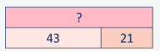
Add 2-digit numbers (across a ten)  Begin to exchange 10 ones for 1 ten. | 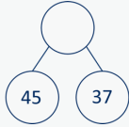  There are …. ones, so I do/do not need to make an exchange.  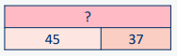  … ones = … ten and … ones  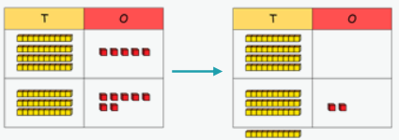  5 ones + 7 ones = 12 ones  12 ones = 1 ten and 2 ones  4 tens + 3 tens + 1 ten = 8 tens  8 tens and 2 ones = 82
Missing numbers Solve missing number problems and use the inverse to check. | How many more do you need to make …?  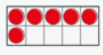  6 + = 10  10 - = 6 | 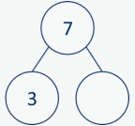  If … is a whole and … is a part, then … is the other part.  = 3 = 7  7 – 3 = |  | … can be partitioned into … and …  10 = 8 = 12 +  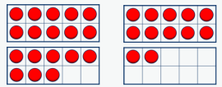

Progression of skills – Subtraction
Year group | Skill
Nursery | - Subitise to 3  - Count how many  - Make numbers to 5  - Take 1 away (through songs and rhymes)
Reception | - Conceptually subitise to 5  - 1 less  - Notice the composition of numbers within 10  - Partition  - Take away
Year 1 | - Find a part  - Take away  - Bonds within 10  - Related facts within 20  - Missing numbers
Year 2 | - Subtract 1s from any number (related facts)  - Subtract across a 10  - Subtract multiples of 10  - Subtract 10s from any number  - Subtract two 2-digit numbers (not across a ten)  - Subtract two 2-digit numbers (across a ten)  - Missing numbers

Nursery | • Begin to have an understanding of numbers to 5  • We recommend focusing on noticing and representing small quantities, perceptual subitising and counting.
Progression of skills | Key representations

Reception | • Have a deep understanding of number to 10, including the composition of each number.  • Subitise (recognise quantities without counting) up to 5  • Automatically recall (without reference to rhymes, counting or other aids) number bonds up to 5 (and some subtraction facts) and some number bonds to 10, including double facts.
Progression of skills | Key representations

Year 1
Progression of skills | Key representations
Progression of skills | concrete | pictorial | abstract

Year 2
Progression of skills | Key representations
Progression of skills | concrete | pictorial | abstract

