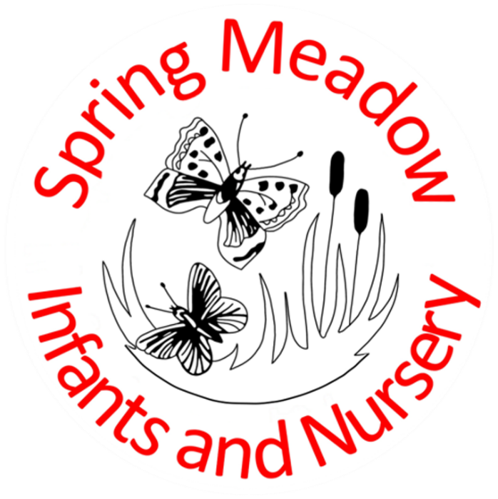
Uniform Policy
December 2024

Lead author/initiator(s): | Laura Fielding
Next Review Date: | April 2026
Version No: | 1
Ratified by: | Spring Meadow Infant and Nursery School Local Governing Body
Date Ratified: | December 2024
Review Timetable: | Biannually

Contents
1. Introduction
2. Aims and Objectives
3. Footwear
4. The Roles of Parents
5. The Role of Governors
6. Monitoring and Reviewing
7. School Uniform List
8. PE Kit
9. Forest School

1. Introduction
It is our school policy that all children wear school uniform when attending school, or when participating in school-organised events outside normal school hours. We ask children to wear their shirts tucked into their skirts or trousers and to take a pride in their personal appearance. Some items of uniform can be bought from school, whilst others are easily available, at very competitive prices, at local shops including supermarkets. A complete list of the items needed for school uniform including those for Physical Education, is included.
2. Aims and objectives
Our policy on school uniform is based on the belief that school uniform:
• promotes a sense of pride in our school;
• helps to create a sense of community and belonging towards the school;
• identifies the children with the school;
• supports our commitment to inclusion;
• is practical, smart and designed with health and safety in mind;
• is considered good value for money by most parents;
Jewellery, Hair Ornaments, and Nail Varnish
For health and safety reasons we do not allow children to wear jewellery. The exceptions to this rule are ear-ring studs in pierced ears or very small sleepers, and small objects of religious significance. Children are required to remove any items during PE lessons to prevent them from causing injury. Please note: Teachers are not permitted to remove earrings. Hair bands, ribbons/bows or ‘scrunchies’ should be plain and either red or white or black. Hair bands should not have large flowers attached. All long hair must be kept neatly tied back for health reasons. Nail varnish should not be worn to school.
3. Footwear
For health and safety reasons we do not allow children to wear shoes with platform soles or high heels. All children are required to wear plain black shoes or trainers. Open toed sandals may not be worn to school for health and safety reasons. If boots are worn these should also be plain black. If boots are large and prevent children from sitting comfortably on the floor they may be asked to change into their PE shoes whilst inside the school building.
4. The Role of Parents
We believe that one of the responsibilities of parents is to ensure that their child has the school uniform and PE kit, and that it is clean, in good repair and that the child’s name is written on all items. If a parent has difficulties for any reason with fulfilling this request they are asked to speak confidentially to a senior member of staff to discuss how we can support you. Parents should be assured that we will do all we can to help. The school welcomes children from all backgrounds and faith communities. If there are serious reasons, for example on religious grounds, why parents want their child to wear clothes that differ from the school uniform, the school will consider such requests sympathetically. If any parent would like to request a modification to the uniform policy they should, in the first instance, contact the head teacher.
5. The Role of Governors
The governing body supports the head teacher in implementing the school uniform policy. It considers all representations from parents regarding the uniform policy and liaises with the head teacher to ensure that the policy is implemented fairly and with sensitivity. It is the governors’ responsibility to ensure that the school uniform meets all regulations concerning equal opportunities. Governors ensure that the school uniform policy enables children to dress sensibly, in clothing that is hardwearing, safe and practical.
6. Monitoring and Review
The governing body monitors and reviews the school uniform policy through its committee work by:
• seeking the views of parents, to ensure that they agree with and support the policy;
• considering, with the head teacher, any requests from parents for individual children to have special dispensation with regard to school uniform;
7. School Uniform List
Our school uniform colour is a combination of red, grey and white. Most items can be bought from high street shops. Sweatshirts, Cardigans and Polo-Shirts can all be purchased with the school logo via the school website.
For girls:
• Grey skirt/pinafore dress/shorts/trousers or red and white checked or striped dresses
• White blouse or polo shirt.
• Red sweatshirt or cardigan, without a hood, either plain or with the Spring Meadow logo
• Plain white short or knee length socks (not over the knee) or
• Black, red or grey tights
For boys:
• Grey shorts or trousers
• White shirt or polo shirt.
• Red sweatshirt, without a hood, either plain or with the Spring Meadow logo
Shoes should be flat, black and appropriate for school. If trainers are worn these should be plain without logos. Your child should wear shoes which he or she can manage to do up independently Please do not send your child to school in shoes which prevent them from running in the playground. If boots are worn these also should be plain black. Children who wear boots that prevent them from sitting comfortably on the floor may be asked to wear their PE shoes whilst inside the building.
8. P.E. Kit
Children need a change of clothes and footwear for P.E (for health and hygiene reasons) and a draw-string bag in which to keep the kit at school. PE kit and PE bags may be bought from the school website. All school uniform and P.E. kit MUST be named. Children can become upset as a result of lost clothing, please help us by naming everything.
Girls and boys wear:
- Black shorts
- Plain Red/ white T-shirt
- A pair of plimsolls – velcro fastenings are helpful for younger children
- A pair of Trainers
- Black jogging bottoms for outdoor lessons in cold weather
- Plain black hoodie/ jumper for outdoor lessons in cold weather
Children are not permitted to wear football kits for PE lessons.
For health and safety reasons children are not permitted to wear earrings for PE. Your child’s teacher will advise you when PE lessons take place so that earrings can be removed.
9. Forest School
Children will need a waterproof jacket and trousers for this activity. A pair of wellington boots is also required. All items can remain in school and will be sent home each half term, or sooner if they become muddy and in need of cleaning.
10. School flexibility
School recognise that there needs to be some flexibility with this policy and welcome any conversations regarding any support or adaptations needed to meet the needs of individuals.

