
Special Educational Needs and Disability (SEND) Policy

Lead author/initiator(s): | Libby Cross
Next Review Date: | September 2027
Version No: | 3
Ratified by: | Spring Meadow Infant and Nursery School Local Governing Body
Date Ratified: | September 2026
Review Timetable: | Annual

Spring Meadow Infant and Nursery School Special Educational Needs and Disability (SEND) Policy

Contents:

1. Introduction
2. What are Special Needs
3. Aims and Objectives
4. Equal Opportunities and Inclusion
5. Identification, Assessment and Provision
6. The Role of the SENCo
7. Monitoring Children’s progress
8. Partnership with Parents
9. The Nature of Intervention
10. Individual Assess, Plan, Do, Review (ADPR) Document
11. Access to the Curriculum
12. Allocation of Resources
13. The Role of the Governing Body
14. Monitoring and Evaluation

- Introduction

Spring Meadow Infant and Nursery School has a named SENDCo (Miss Libby Cross) and a named Governor responsible for SEND – David Barker (Chair). They ensure that the Special Educational Needs and Disabilities policy works within the guidelines and inclusion policies of the SEND Code of Practice (2014), the Local Education Authority and other policies current within the school.

At Spring Meadow, it is the belief that all children have an equal right to a full and rounded education which will enable them to achieve their full potential. We use our best endeavors to secure special educational provision for pupils for whom this is required. ‘Additional to and different from’ provision is provided, where required, within a differentiated curriculum to help to better respond to the four areas of need identified in the SEND Code of Practice.

• Communication and interaction
• Cognition and learning
• Social, mental, and emotional health
• Sensory/physical

- What are special educational needs?

A child or young person has special educational needs if they have a learning difficulty or disability which calls for special educational provision to be made for them. A learning difficulty or disability is a significantly greater difficulty in learning than the majority of others of the same age. Special educational provision means educational or training provision that is additional to, or different from, that made generally for others of the same age in a mainstream setting in England. Health care provision or social care provision which educates or trains a child or young person is to be treated as special educational provision. (SEND Code of Practice 2014)

This SEND policy details how we will do our best to ensure that the necessary provision is made for any pupil who has special educational needs and that those needs are known to all who are likely to work with them. We will ensure that teachers are able to identify and provide for those pupils with special educational needs, allowing them to join in all school activities together with pupils who do not have special educational needs.

- Aims and objectives

The aims of this policy are:

• To create an environment that meets the special educational needs of each child in order that they can achieve their learning potential and engage in activities alongside pupils who do not have SEND
• To request, monitor and respond to parent/carer and pupil views to evidence high levels of confidence and partnership
• To make clear the expectations of all partners in the process
• To ensure a high level of staff expertise to meet pupil need, through well targeted continuing professional development
• To ensure support for pupils with medical conditions full inclusion in all school activities by ensuring consultation with health and social care professionals
• To identify the roles and responsibilities of all staff in providing for children’s special educational needs
• Through reasonable adjustments to enable all children to have full access to all elements of the school curriculum
• To work in cooperation and productive partnerships with the Local Education Authority and other outside agencies, to ensure there is a multi-professional approach to meeting the needs of all vulnerable learners

- Equal Opportunities and Inclusion

Through all subjects we ensure that the school meets the needs of all, taking account of gender, ethnicity, culture, religion, language, sexual orientation, age, ability, disability, and social circumstances. It is important that in this school we meet the diverse needs of pupils to ensure inclusion for all and that all pupils are prepared for full participation in a multi-ethnic society.

Through appropriate curricular provision, we respect the fact that children:

• Have different educational and behavioural needs and aspirations
• Require different strategies for learning
• Acquire, assimilate, and communicate information at different rates
• Need a range of different teaching approaches and experiences

Teachers respond to children’s needs by:

• Providing support for children who need help with communication, language, and literacy
• Planning to develop children’s understanding using all available senses and experiences
• Planning for children’s full participation in learning, and in physical and practical activities
• Helping children to manage and own their behaviour and to take part in learning effectively and safely
• Helping individuals to manage their emotions, particularly trauma or stress, and to take part in learning

- Identification, Assessment and Provision

Provision for children with special educational needs is a matter for the whole school. The Governing Body, the school’s Head teacher, the SENDCO and all other members of staff, particularly class teachers and teaching assistants.

The school will assess each child’s current levels of attainment on entry to ensure that they build on the patterns of learning and experience already established during the child’s pre- school years. If the child already has an identified special educational need, this information may be transferred from other partners in their Early Years setting and the class teacher and SENDCO will use this information to:

• Provide starting points for the development of an appropriate curriculum.
• Identify and focus attention on action to support the child within the class.
• Use the assessment processes to identify any learning difficulties.
• Ensure ongoing observation and assessments provide regular feedback about the child’s achievements and experiences to form the basis for planning the next steps of the child’s learning.

The identification and assessment of the special educational needs of children whose first language is not English requires particular care. Where there is uncertainty about a particular child, a teacher will look carefully at all aspects of the child’s performance in different subjects to establish whether the problems are due to limitations in their command of English or arises from special educational needs.

- The Role of the SENCO

The Special Educational Needs and Disabilities Co-Ordinator’s [SENDCO] responsibilities include:
• Overseeing the day-to-day operation of the school’s SEND policy.

• Co-ordinating provision for children with SEND.
• Liaising with and advising fellow teachers.
• Overseeing the records of all children with SEND.
• Liaising with parents of children with SEND.
• Contributing to the in-service training of staff.
• Liaising with external agencies.
• Co-ordinating and developing school-based strategies for the identification and review of children with SEND.
• Monitor the progress of children on the SEND register ensuring there is a clear system of Assess, Plan, Do, Review in place.

- Monitoring Children’s Progress

The school’s system for observing and assessing the progress of individual children will provide information about areas where a child is not progressing satisfactorily. Under these circumstances, teachers may need to consult the SENDCO to consider what else might be done. This review might lead to the conclusion that the pupil requires help over and above that which is normally available within the particular class or subject.

The key test of the need for action is that current rates of progress are inadequate. Adequate progress can be identified as that which:

• Prevents the attainment gap between the child and his peers from widening.
• Closes the attainment gap between the child and his peers.
• Betters the child’s previous rate of progress.
• Ensures access to the full curriculum.
• Demonstrates an improvement in self-help, social or personal skills.
• Demonstrates improvements in the child’s behaviour.

Spring Meadow Infant and Nursery School undertakes a constant Assess, Plan, Do and Review process where we evaluate our interventions, our teaching, and the impact. This allows us to effectively plan our support for pupils with SEND. We use a graduated approach where a child can access appropriate levels of support based on need, this is outlined below:

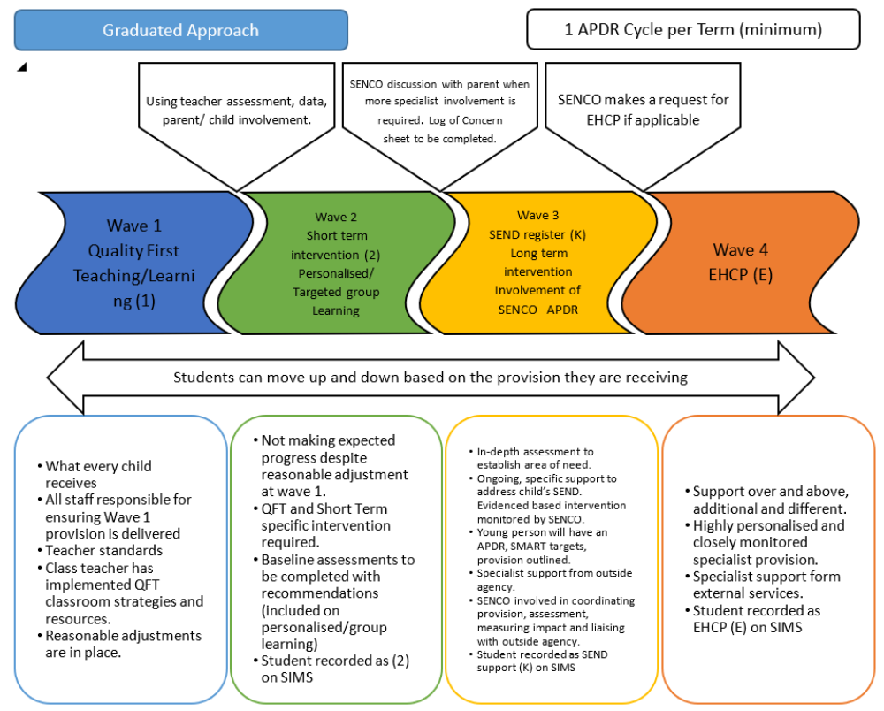

When any concern is initially noticed it is the responsibility of the class teacher to take steps to address the issue.

A pupil at wave 1 may have small reasonable adjustments that are made to ensure they can access the teaching and learning in the classroom. Adjustments could be: coloured glasses, a writing slope, a triangular pencil etc.

When reasonable adjustments are not enough to ensure the pupil is making the expected progress then the pupil would move to wave 2. The class teacher would ensure the pupil has group intervention or personalised learning that is targeted to fill the gaps in learning and ensure progress. Parents may be consulted, and specific intervention monitored for an agreed period. If progress is made following the specific intervention the teacher would decide if the support should continue or the pupil will move back down to wave 1. If no progress is noted after this time the teacher will meet with the parent to complete an initial concern form. The child will then be added to the school SEND register at (K), in consultation with the parent/carer.

If a child is accessing more help and support than the majority of children of that age, or they are working at a level increasingly below age related, often requiring a need for outside agency support then they are placed on the SEND register at ‘K’ code or wave 3 and teachers produce an APDR (Assess, Plan, Do, Review) document. This identifies targets and strategies to support that child, and these are monitored by the class teacher and teaching assistants within the class. This process is discussed with parents and carers at the initial ‘plan’ meeting and at the ‘review’ stage and involves children and their thoughts as appropriate. APDR’s will be reviewed formally at least termly with the parents and young person (as appropriate).

The SENDCO will have responsibility for ensuring that records are kept and available when needed.
Reasons for a child being added to the SEND register (K) may include the fact that he/she:

• Makes little or no progress, even when teaching approaches are targeted particularly in a child’s identified area of weakness.
• Shows signs of difficulty in developing literacy or mathematics skills which result in poor attainment in some curriculum areas.
• Presents persistent emotional or behavioural difficulties which are not improved by the behaviour management techniques usually employed in the school.
• Has sensory or physical problems, and continues to make little or no progress, despite the provision of specialist equipment.
• Has communication and / or interaction difficulties and continues to make little or no progress.
• Is accessing the Early Support pathway for children under 5 years of age.

Children with an Education, Health, and Care Plan or who are at wave 4 will also have an Assess, Plan, Do, Review (APDR) which links closely to their EHCP. Education, Health, and Care Plans are also reviewed annually (or 6 monthly for children under 5). Reviews involve class teachers, parents, professionals, support staff, SEND Leader and children (as appropriate). If it is not appropriate for children to attend the meeting their views will be collected in the best ways for them, this maybe through drawings, collage, conversations with adults, film clippings, schoolbooks etc. Education, Health, and Care Plan review meetings can also be called by anyone involved with the child at a time earlier than required, this is often called ‘An Emergency Annual Review’. All paperwork for any EHCP annual review is completed by the SEND Leader or Teacher of the Enhanced Resource Provision and submitted to the Statutory Assessment Team for updating.

- Partnership with parents

Partnership plays a key role in enabling children and young people with SEND to achieve their potential. Parents hold key information and have knowledge and experience to contribute to the shared view of a child’s needs. All parents of children with special educational needs will be treated as partners given support to play an active and valued role in their child’s education.

Children and young people with special educational needs often have a unique knowledge of their own needs and their views about what sort of help they would like. They will be encouraged to contribute to the assessment of their needs, the review and transition process.

The school website contains details of our school information report as well as a link to the Cambridge shire Local Offer:
https://www.cambridgeshire.gov.uk/residents/children-and-families/local-offer/about-cambridgeshire-s-local-offer/

At all stages of the special needs process, the school keeps parents fully informed and involved. We take account of the wishes, feelings, and knowledge of parents at all stages.

We encourage parents to make an active contribution to their child’s education and have regular meetings each term to share the progress of special needs children with their parents. We inform the parents of any outside intervention and share the process of decision-making by providing clear information relating to the education of their child.

- The Nature of Intervention

The SENDCO and the child’s class teacher will decide on the action needed to help the child progress in the light of earlier assessments. This may include:

• Different learning materials or specialist equipment.
• Some group or individual support, which may involve small groups of children being withdrawn to work with TA support or Teacher for specific intervention.
• Extra adult time to devise/administer the nature of the planned intervention and to monitor its effectiveness.
• Staff development and training to introduce more effective strategies.

After initial discussions with the SENDCO, the child’s class teacher will be responsible for working with the child daily and ensuring delivery of any individualized program in the classroom. Parents will continue to be consulted and kept informed of the action taken to help their child, and of the outcome of any action. Parents will be invited to meet regularly with the class teacher and or SENDCO to discuss Individual Learning targets and progress.

The SENDCO will support further assessment of the child where necessary, assisting in planning for their future needs in discussion with colleagues and parents.

The use of outside agencies:

These services may become involved if a child continues to make little or no progress despite considerable input and adaptations. They will use the child’s records in order to establish which strategies have already been employed and which targets have previously been set.

The external specialist may act in an advisory capacity or provide additional specialist assessment or be involved in teaching the child directly. The child’s individual targets will set out strategies for supporting the child’s progress. These will be implemented, at least in part, in the normal classroom setting. The delivery of the interventions recorded in the APDR continues to be the responsibility of the class teacher.

Outside agencies may become involved if the child:

• Continues to make little or no progress in specific areas over a long period.
• Continues to work substantially below that expected of children of a similar age.
• Continues to have difficulty in developing literacy and mathematical skills.
• Has emotional or behavioural difficulties which regularly and substantially interfere with the child’s own learning or that of the class group.
• Has sensory or physical needs and requires additional specialist equipment or regular advice or visits by a specialist service.
• Has ongoing communication or interaction difficulties that impede the development of social relationships and cause substantial barriers to learning.
• Despite having received intervention, the child continues to fall behind the level of his peers.

School Request for an Education Health and Care Plans

A request will be made by the school to the LA if the child has demonstrated significant cause for concern. The LA will be given information about the child’s progress over time, and will also receive documentation in relation to the child’s special educational needs and any other action taken to deal with those needs, including any resources or special arrangements put in place.

The evidence will include:

• Previous individual, assess, plan, do, review documents and targets for the pupil.
• Previous information gathered from group or personalised learning documents
• Records of regular reviews and their outcomes, including Team Around the Family (TAF) notes and reviews.
• Records of the child’s health and medical history where appropriate.
• Attainment in literacy and numeracy.
• Education and other assessments, for example from an advisory specialist support teacher or educational psychologist.
• Views of the parents.

The parents of any child who is referred for an Education Health and Care Plan will be kept fully informed of the progress of the referral.

- Individual Assess, Plan, Do Review (APDR) document

Strategies employed to enable the child to progress will be recorded within an Individual Plan (APDR). This will ensure there is a clear system of Assess, Plan, Do, Review and will include information about:

• The child’s current achievements
• The longer-term outcomes for the child
• What are the steps needed to make progress towards the outcome
• The short-term SMART targets set for the child
• The teaching strategies to be used
• The provision to be put in pace
• How the target will help the child in their learning
• How the child can be successful
• The review dates
• The child’s views will be sought and considered, as will those of the parents, whose support is vital if progress is to be achieved and maintained
• After the agreed period of time to implement the provision the APDR is then reviewed with parents and pupils (as appropriate). Comments are made about if the child has met their target and what are the next steps.

- Access to the Curriculum

All children have an entitlement to a broad and balanced curriculum, which is differentiated to enable children to understand the relevance and purpose of learning activities and experience levels of understanding and rates of progress that bring feelings of success and achievement.

Teachers use a range of strategies to meet children’s special educational needs. Lessons have clear learning objectives and staff differentiate work appropriately and use assessment to inform the next stage of learning. All children on the special needs register have an Assess, Plan, Do, Review document with individual targets.

We support children in a manner that acknowledges their entitlement to share the same learning experiences that their peers enjoy. Wherever possible, we do not withdraw children from the classroom situation. There are times though when, to maximise learning, we ask the children to work in small groups, or in a one-to-one situation outside the classroom.

- Allocation of Resources

The SENDCo is responsible for the operational management of the specified and agreed resourcing for special needs provision within the school, including the provision for children with Education Health and Care plans.

The Head teacher informs the Governing Body of how the funding allocated to support special educational needs has been employed.

The Head teacher and the SENDCo meet regularly to agree on how to use funds directly related to Education Health and Care Plans

- The role of the Governing Body

The Governing Body challenges the school and its members to secure necessary provision for any pupil identified as having special educational needs. They ask probing questions to ensure all teachers are aware of the importance of providing for these children and ensure that funds and resources are used effectively.

The Governing Body has decided that children with special educational needs will be admitted to the school in line with the school’s agreed admissions policy.

The Governing Body reviews this policy annually and considers any amendments the annual review findings. The Head teacher reports the outcome of the review to the full Governing Body.

- Monitoring and evaluation

The SENDCO monitors the movement of children within the SEND system in school and provides staff and Governors with regular summaries of the impact of the policy on the practice of the school. They are involved in supporting teachers and in drawing up Assess, Plan, Do, Review documents for children if required. The SENDCo and the Head teacher hold regular meetings to review the work of the school in this area. In addition, the SENDCo and the named Governor with responsibility for special needs also hold regular meetings.

