
Rhyme Time – Seaside Adventures
Welcome to Rhyme Time with Caterpillar and Butterfly classes!
The children are learning about animals that live in the ocean and exploring materials through the book Sharing a Shell and here are some of the songs that you could sing with them at home.
Teaching nursery rhymes to your young children has many benefits such as stimulating language development and introducing children to the sounds, rhythms and sequencing that language is comprised of. Nursery rhymes encourage early literacy skills which support reading and writing through repeated structures, patterns and rhyme.


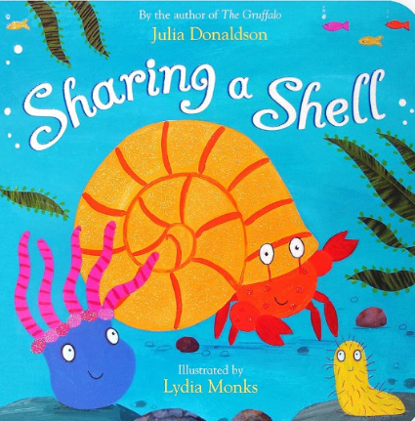
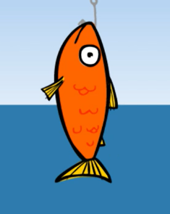
1, 2, 3, 4, 5, Once I caught a fish alive
One, two, three, four, five,
Once I caught a fish alive.
Six, seven, eight, nine, ten,
Then I let it go again.
Why did you let it go?
Because it bit my finger so.
Which finger did it bite?
This little finger on the right.
One, two, three, four, five,
Once I caught a crab alive.
Six, seven, eight, nine, ten,
Then I let it go again.
Why did you let it go?
Because it bit my finger so.
Which finger did it bite?
This little finger on the right.



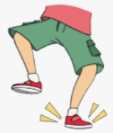
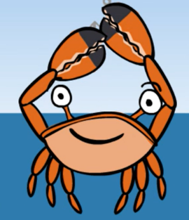
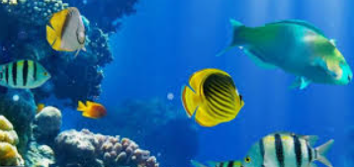
If you're happy and you know it

If you’re happy and you know it,
Clap your hands.
If you're happy and you know it,
Clap your hands.
If you're happy and you know it,
And you really want to show it,
If you're happy and you know it,
Clap your hands.

Use this QR code to see Julia Donaldson telling her story on a beach and the illustrator drawing characters from the book.
We’re Going for a Paddle (To the tune of Ring-a-ring o’ roses)

We’re going for a paddle
We’re going for a big splash
A wave comes along,
And back we dash.

Fishes in the water,
Fishes in the sea,
We all jump in with a 1, 2, 3!
The Waves in the Sea
(sung to the tune of The Wheels on the Bus)
The waves in the sea go,
Up and down, (make a rolling wave by moving one hand up and down)
Up and down,
Up and down,
The waves in the sea go,
Up and down,
All day long.
The sharks in the sea go,
Snap, snap, snap… (hold two hands together, joined at the wrist, to form a mouth, snap open and shut)
The fish in the sea go,
Swish, swish, swish… (swim hands around as fish)
The crabs in the sea go
Click, click, click… (click fingers)

