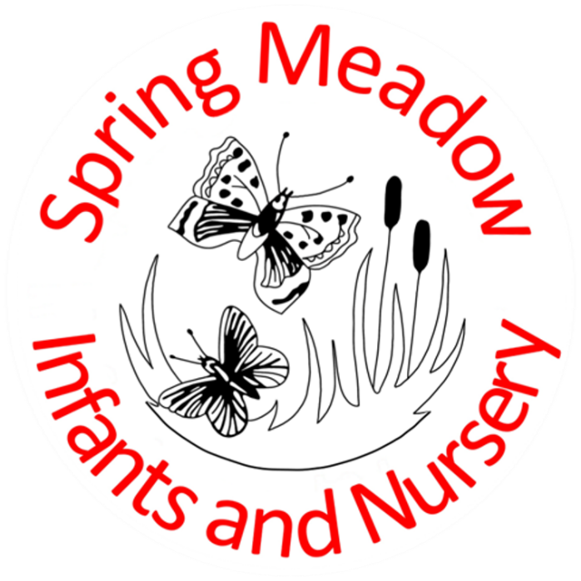

Charging and Remissions Policy

Lead author/initiator(s): | Zoe Thistlethwaite (Finance Manager)
Next Review Date: | November 2027
Version No: | 2
Ratified by: | Spring Meadow Infant and Nursery School Local Governing Body
Date Ratified: | 11.11.2025
Review Timetable: | Bi-annually

Purpose
We aim to provide a broad, balanced curriculum for pupils within our care. However, it is recognised that many educationally valuable activities have been, and will continue to be, dependent on financial contributions from parents. Without that financial support the school would find it impossible to maintain the quality and breadth of educational experiences provided for pupils. However, the school will look at alternative ways of funding where it is possible to minimise charges.

Have robust, clear processes in place for charging and remissions

Definitions

For the purposes of this policy the following definitions will be used:

Charge: a fee payable for specifically defined activities.

Remission: the cancellation of a charge, partly or wholly, which would normally be payable

Legislation and guidance
This policy is based on advice from the Department for Education (DfE) on charging for school activities and the Education Act 1996, sections 449 to 462 of which set out the law on charging for school activities in England. Academies are required to comply with this Act through their funding agreements.
It’s also based on guidance from the DfE on statutory policies for schools and academy trusts.
This policy complies with our funding agreement and articles of association.

Responsibilities
The Governors, in consultation with the Headteacher, are responsible for the implementation of the charging policy and the determination of any individual case arising from the implementation of this policy.

We will make a charge for:
- Day and part day educational visits. For visits during school time, the Headteacher will invite voluntary contributions from parents to meet the cost of the visit. Every effort will be made to keep these costs reasonable. However, where voluntary contributions are insufficient to cover the costs involved, the visit or activity may be cancelled. Pupils will not be treated differently according to whether their parents have made any contribution.

- Extra-curricular clubs. Extra-curricular clubs normally happen outside the school day. The school may take a charge for Clubs e.g.Baking Club, Art and Crafts. The afterschool clubs will vary in cost. Children who are eligible for Pupil premium will be offered one free club per term.

- Nursery sessions above the funded hours will be charged at £25.00 for 2 year olds while 3 and 4 year olds are charged at £18.00. Non-funded nursery lunches will be processed onto the Arbor system at a cost of £2.20 a meal.

- Late pick up from Nursery will be charged at £5.00 per incident.

- Nursery meals will not be offered until the debt of £50.00 or more is settled.

Calculating charges

When charges are made for any activity, whether during or outside the school day, they will be based on the actual costs incurred, divided by the total number of pupils participating. There will be no levy on those who can pay to support those who cannot.

Payments to school

The school anticipates all debts to be paid within 30 days of the invoice/transaction raised. If debts are not paid and raise above £50.00 will be chased with the first step of our 3-step stage of recurring debts letters. Appendix 1. This will be chased in the future by second and third letters to ensure the debt is received. All debts are reviewed monthly at the beginning of the month.

Tax free childcare payment
The school accepts tax free childcare payments which are actioned by parents/carers on https://www.gov.uk/apply-for-tax-free-childcare. The school requires notification by email finance@springmeadow.cambs.sch.uk of the transaction which will be paid into the school bank account. The child’s surname and the amount paid. The payment transaction will be deducted from the internal school payment system Arbor when the monthly bank reconciliation is completed.

Remissions
In circumstances of family hardship that makes it difficult for pupils to take part in particular activities for which a charge is made, or where parents are in receipt of family credit or income support, the school will invite parents to apply in confidence for the remission of charges in part or in full. Authorisation of remissions will be made by the Headteacher and will be at their complete discretion but subject to guidance, if any, by the Governing Body.

Arrangements for monitoring and evaluation

This policy will be reviewed bi-annually by the Governors Finance Committee and may be amended as appropriate. Any eventuality not covered by this policy will be considered by the Headteacher and Governors and a decision made in line with the LA Policy of Charging.

Step 1

[Date]

Subject: Outstanding debt– [Child’s Name / AMOUNT]

Dear [Parent/Guardian],

Our records show an outstanding balance of £[amount] for [Child’s Name]. This may simply be an oversight, and we kindly ask that payment is made within 14 days on Arbor or by BACS [reference with child’s surname].

Account Name: Spring Meadow Infant & Nursery
Sort Code: 52-10-46
Account No. 25739042

If you have already paid, please disregard this letter. Should you be experiencing financial difficulties, please contact me by email finance@springmeadow.cambs.sch.uk.

Thank you for your prompt attention to this matter.

Yours sincerely
Zoe Thistlethwaite
Finance Manager

Step 2

[Date]

Dear [Parent/Guardian Name]

Subject: Outstanding Balance – [Child’s Name / AMOUNT]

Dear [Parent/Guardian],

We are writing to remind you that there is an outstanding balance of £[amount] on your account relating to [nursery meals/ nursery sessions after-school activities] for [Child’s Name].

As of today, this balance remains unpaid despite our earlier reminders. We kindly request that the full payment is made by [due date, e.g., within 7 days of this letter].
Payment can be made via Arbor or BACS [reference child’s surname]

Account Name: Spring Meadow Infant & Nursery
Sort Code: 52-10-46
Account No. 25739042

If you have already settled this amount, please disregard this letter.

If you are experiencing difficulties in making payment, please contact us as soon as possible to discuss a suitable arrangement on finance@springmeadow.cambs.sch.uk. It is important that we hear from you promptly to avoid any disruption to [Child’s Name]’s access to [services/activities].

Please consider this letter a final reminder before further action may be necessary.

Yours sincerely

Zoe Thistlethwaite
Finance Manager

Step 3

[Date]

Subject: Final warning outstanding debt– [Child’s Name / AMOUNT]

Dear [Parent/Guardian],

Despite our previous reminders, the outstanding balance of £[amount] for [Child’s Name] remains unpaid.

This letter serves as final notice. Unless payment is received by [date], we will proceed with further action. This will include suspension of [meals/sessions] and/or referral to external debt recovery, which may result in additional costs being added to your account.

If you are experiencing difficulties in making payment, please contact us as soon as possible to discuss a suitable arrangement on finance@springmeadow.cambs.sch.uk.

Could you settle this matter immediately to avoid escalation.
Payment can be made via Arbor or BACS [reference child’s surname]

Account Name: Spring Meadow Infant & Nursery
Sort Code: 52-10-46
Account No. 25739042

Yours sincerely

Zoe Thistlethwaite
Finance Manager

